**Project Proposal**

**Introduction to sailing**

Sailing is a competitive sport that is played between individuals. Each individual sits in a boat that he is responsible for controlling, and his aim is to control the boat to round buoys in some pre-determined prescribed order. The player is responsible for controlling the sail and rudder of the boat in response to the wind.

The angle that the boat makes with regards to the direction at which the wind is coming from determines what point of sail he is in. Figure 1 lists the possible points of sail and the optimum angle the sail makes with the boat at each point.

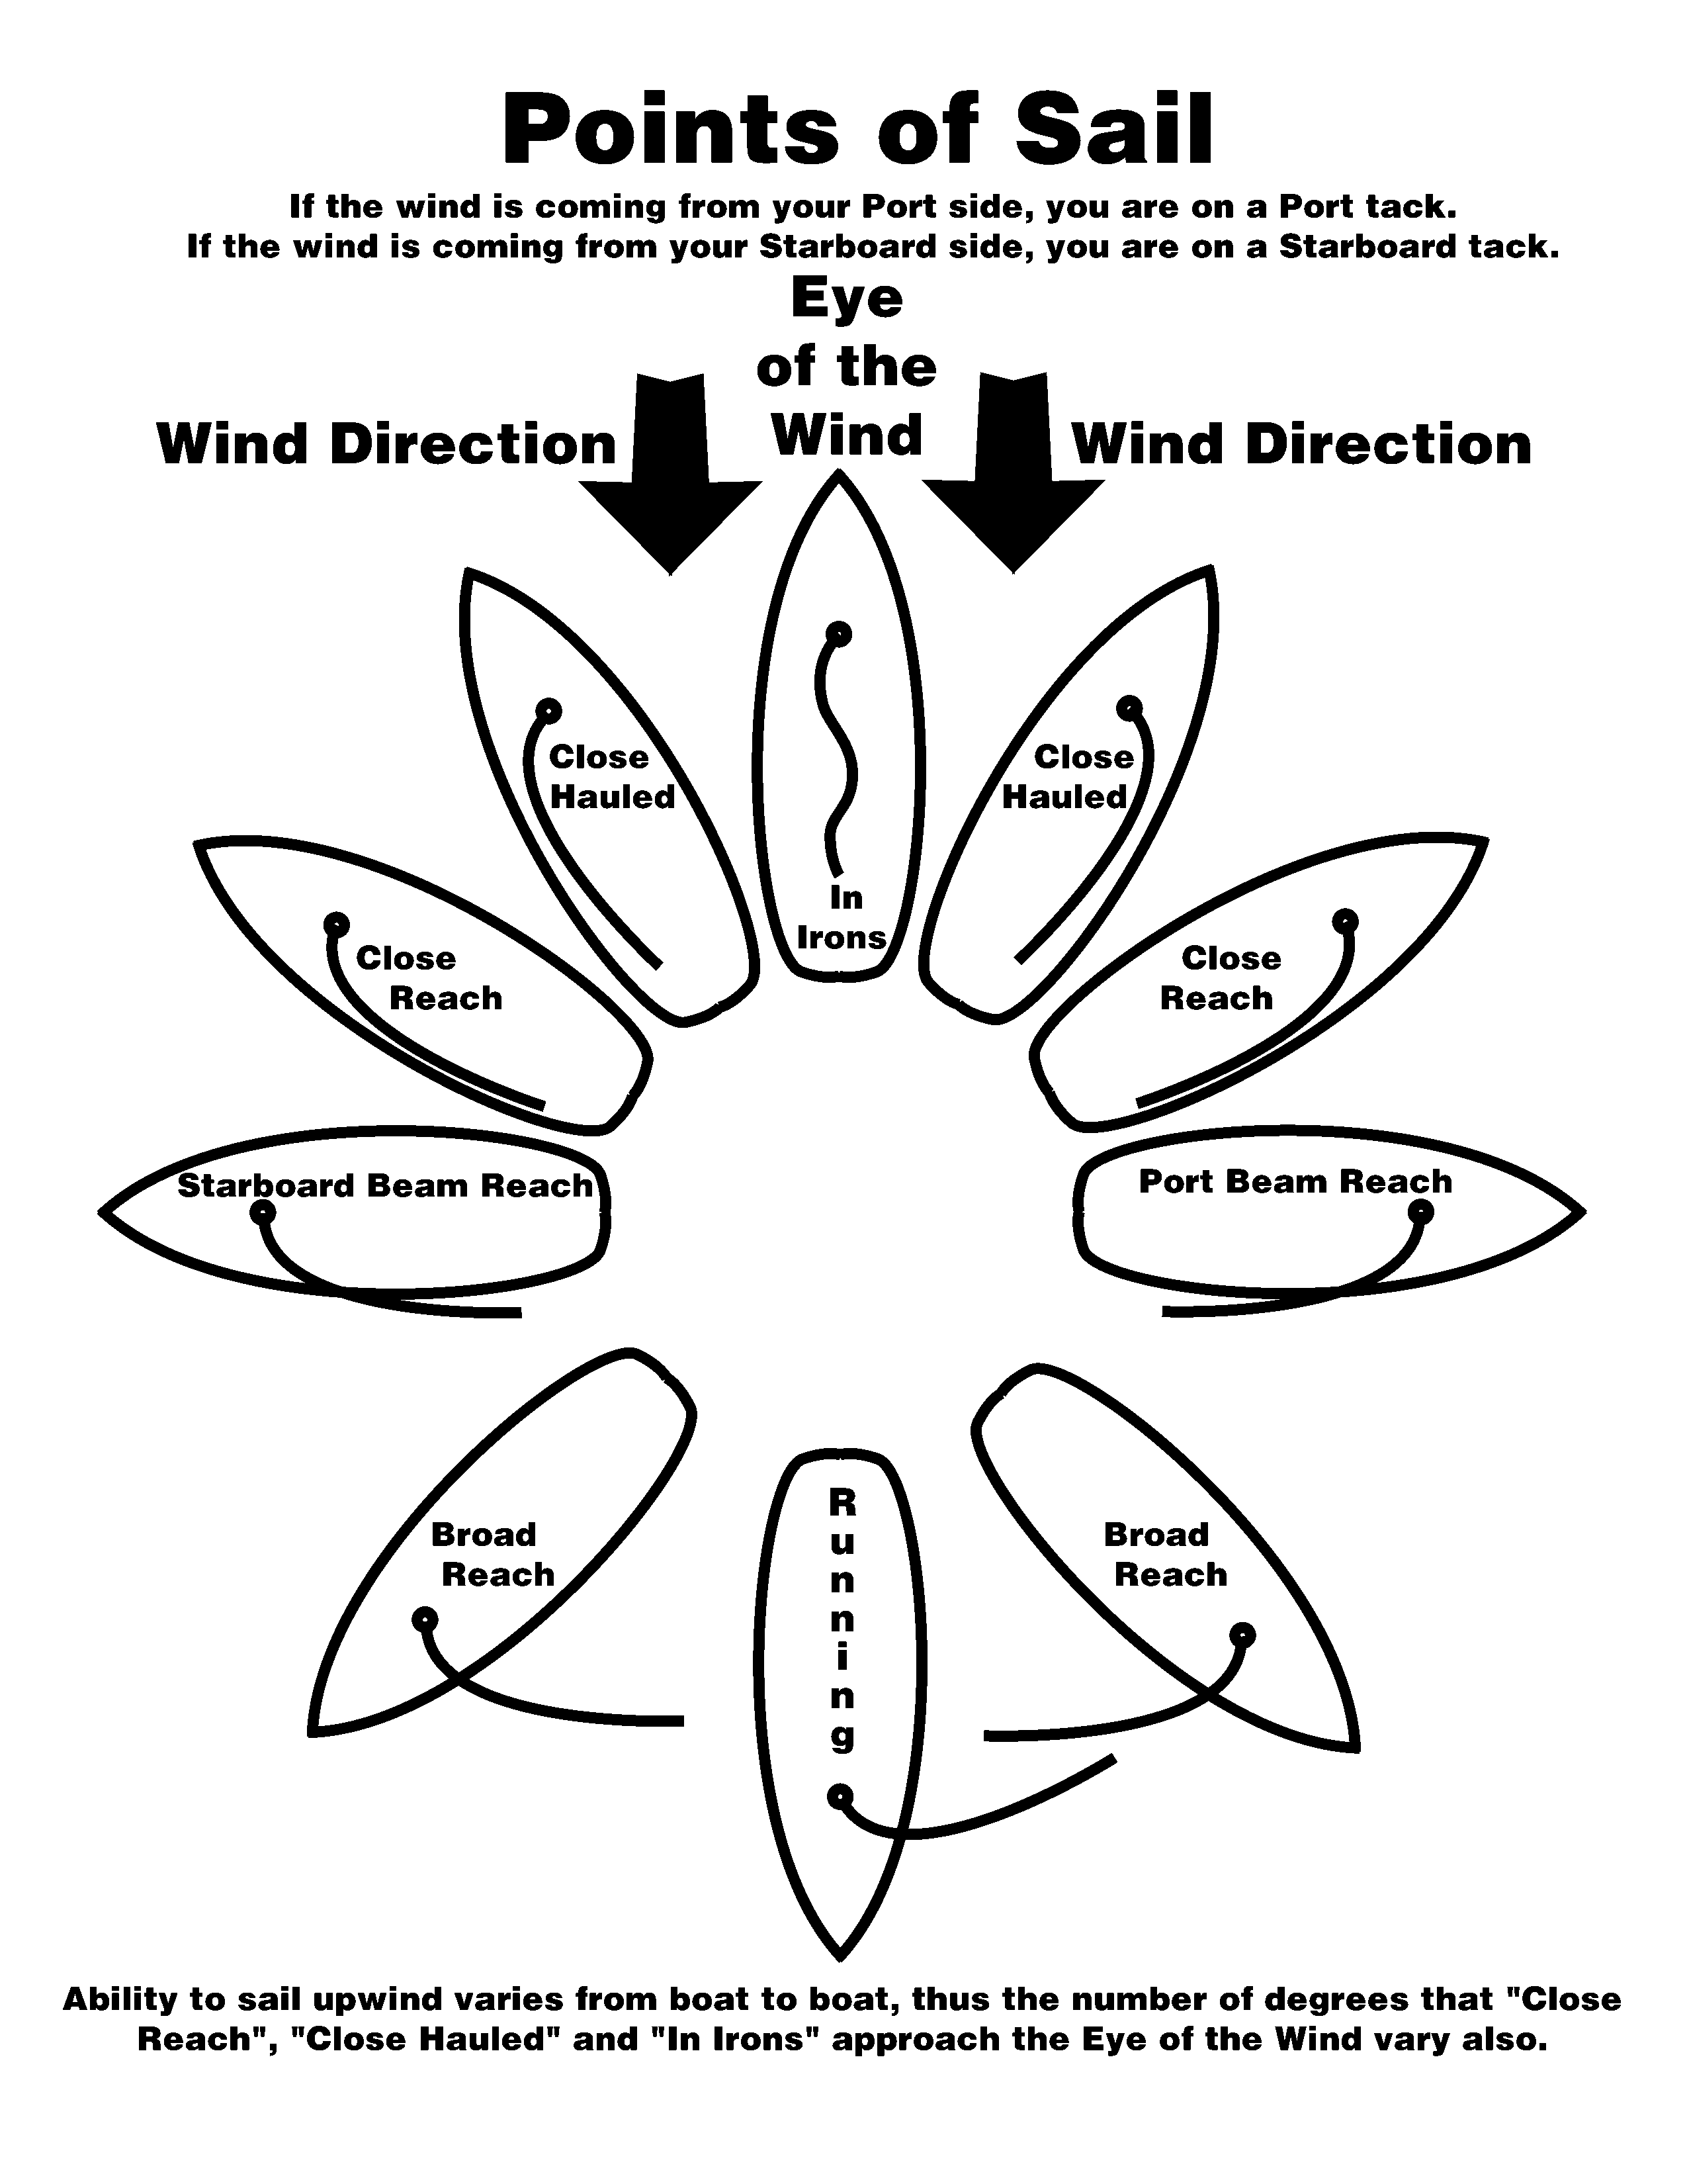

Figure Points of sail (Source: http://premiantrealty.com/static/pointsofsail.gif)

**Introduction to as-yet-unnamed game**

I propose a multi-staged sailing simulator that contains elements of the existing simulators as mentioned in my competitive analysis, SailX and The Pirate King.

The player has to use the 4 arrow keys to move the boat and sail in the game. He is able to rotate the boat clockwise and counterclockwise, and move the sail in and out. The combination of these and the wind direction will determine how fast he is moving.

**Games stages**

Users have to first undergo a general introduction to sailing fused with an introduction to the game controls. Referring to Figure 1 above, he first has to practice moving on a beam reach and running, before trying out moving in a close haul.

Next, he is eligible to move into a single player mode, racing with computer-players to round buoys in a prescribed order. During each time the single player mode is played, the wind direction and speed is randomly generated, providing an element of change and excitement to the game.

There is also room for a multiplayer mode, where another user sharing the same keyboard controls another boat. I also plan to have a cross-platform multiplayer mode.

**Game implementation**

I plan to use Pygame to in designing the game, and PodSixNet in giving it multiplayer functionality.

I intend to hardcode the positions of each buoy in each level of the game, and the coordinates of a few points around the buoy. If the coordinates of the boat fall within these bounds, it will be taken that the player has rounded a buoy.